Game Design Document

Fill up the following document

1. Write the title of your project.

Catch The Butterflies

1. What is the goal of the game?

A girl has to catch all the butterflies clearing all the obstacles.

1. Write a brief story of your game.

There is a girl who is really fond of butterflies. Hence, she goes in a jungle to grab butterflies. There, she has to face all the obstacles to catch the butterflies.

1. Which are the playing characters of this game?

* Playing characters are the ones who respond to the user based on the input from the user.
* The girl is the playing characters in the game.

|  |  |  |
| --- | --- | --- |
| Number | Character Name | What can this character do? |
| 1 | Girl | It can run and jump |

1. Which are the Non-Playing Characters of this game?

* Non-Playing characters are the ones that don't have an action or behavior when the user interacts with the game.
* Butterflies, trees and animals etc., are non-playing characters in the game.

|  |  |  |
| --- | --- | --- |
| Number | Character Name | What can this character do? |
| 1 | Butterflies | They are like the points/coins which the girl has to catch |
| 2 | Trees | These are the obstacles |
| 3 | Animals | They can move and make the player lose |

Draw your imagination of this game. What does this game look like?

* Draw the game either on your computer or on paper.
* Add images of the game scenes to show each of the playing and non-playing characters at least once.

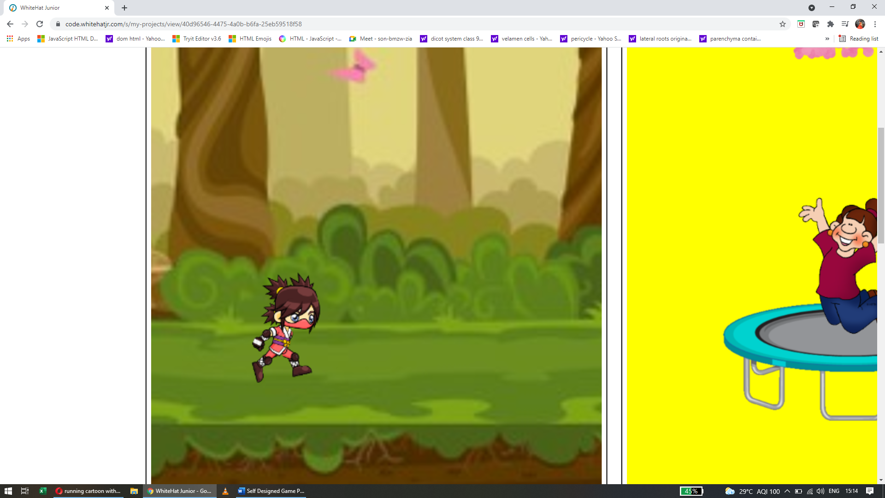

How do you plan to make your game engaging?

There would be many obstacles, so the player would be engaged in the game. It won’t be too easy, or too hard either.